LAB # 06

**Objective :** To learn RMI-IIOP

**Task :** Create RMI IIOP application in which take a sentence at runtime on the client application and let the server return its reverse.

**Interface:**

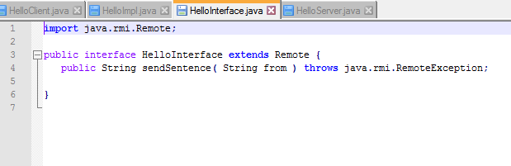

**PortableRemote:**

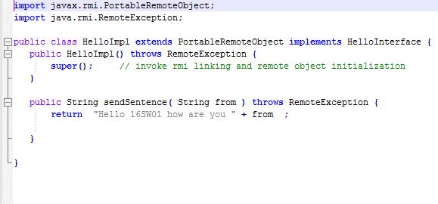

**Server :**

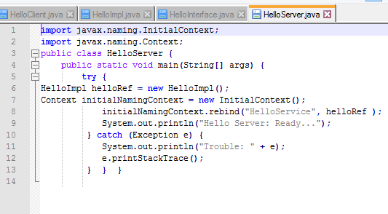

**Client :**

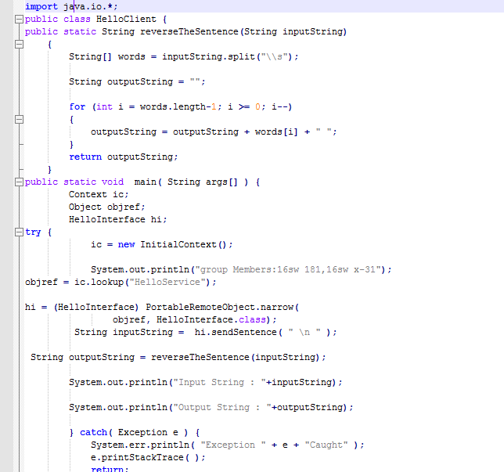

OUTPUT:

